Distance Learning: Adapting Education Beyond Boundaries

In the digital age, distance learning has emerged as a transformative method of education delivery. This method allows students to access educational content remotely, breaking down geographical barriers and enabling flexible learning schedules. Distance learning encompasses various online platforms, video lectures, and interactive assignments.



Figure 1. Students Engaged in Online Learning

Student engagement is “the degree of attention, curiosity, interest, optimism, and passion” students express during the class. In other words, it’s their will and ability to get involved in the learning process.

|  |  |
| --- | --- |
| Time Slot | Activities |
| Morning | Lecture 1, Read Material |
| Afternoon | Participate in Discussion Forum |
| Evening | Complete Assignment 2 |

Table1: Time Management in Distance Learning

One of the advantages of distance learning is its flexibility. Table 1 illustrates how students can manage their time effectively, balancing coursework with other commitments.

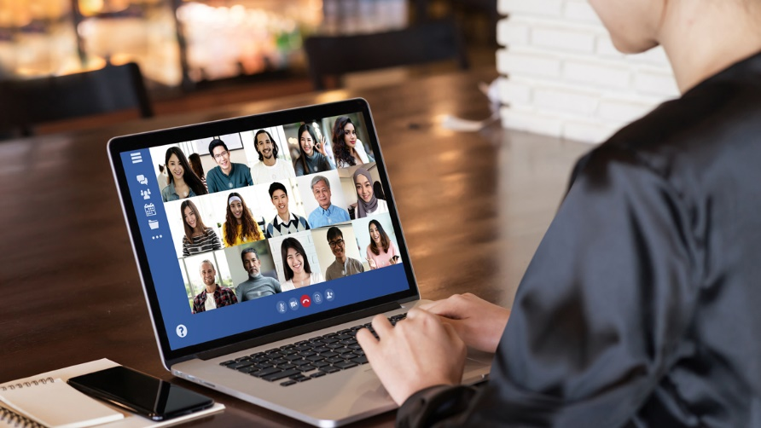

Figure 2: Virtual Collaboration Among Students

As shown in Image 2, collaboration among students isn't compromised in the online environment. Virtual group projects and video conferences allow students to interact and learn from each other, despite physical separation.

|  |  |
| --- | --- |
| Pros | Cons |
| Flexibility | Lack of Face-to-Face Interaction |
| Global Reach | Technical Challenges |
| Self-Directed | Distractions at Home |

Table 2: Pros and Cons of Distance Learning

|  |  |  |
| --- | --- | --- |
| Aspects | Traditional Classroom Learning | Distance Learning |
| Interaction | In-Person Discussions | Virtual Discussions |
| Learning Environment | Physical Classroom | Any Location with Internet |
| Assessment | Paper Exams | Online Quizzes and Assignments |

Table 3: Comparison of Learning Approaches

Distance learning's effectiveness is further demonstrated in Table 3, which compares traditional classroom learning with online learning.

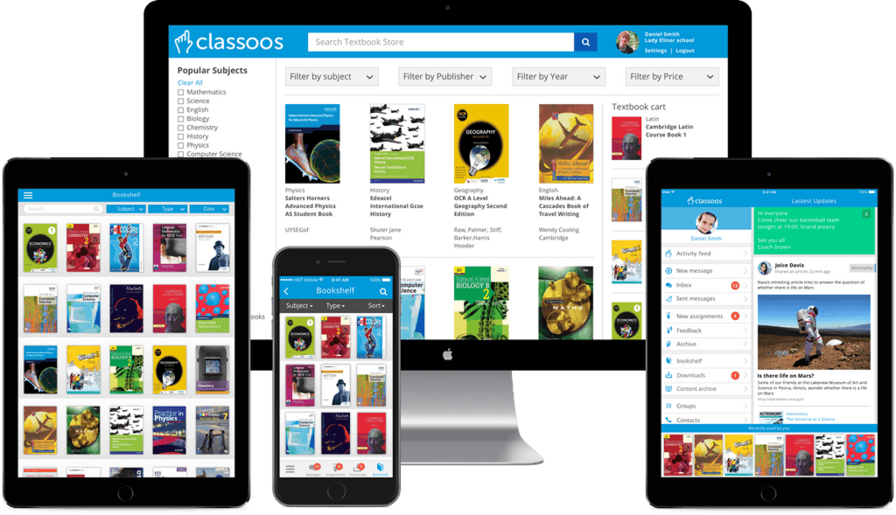

Figure 3: Digital Resources for Learning

As the world becomes more interconnected, distance learning provides a gateway to quality education for individuals who might otherwise face barriers. With the right tools and strategies, this approach is shaping the future of education.



Figure 4: Online Library and Resources

For any service that asks for a User ID or PIN, your User ID is your library card number (with no spaces) and your PIN is the last four digits of your phone number. If you have a Buncombe County or Asheville City school ID card, your ID is your card number and your PIN is the last four digits of your ID number.

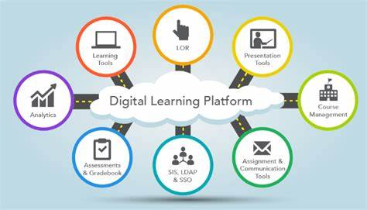

Figure 5: E-Learning Platforms

There are many authoring tool solutions out there that are worth exploring such as SAP Litmos and Linkedin Learning, but to make life a little easier for you, we’ve round up the 10 most popular online learning platforms

Reference:

1. Smith, J. A. (2020). Digital Education: Strategies for Effective Online Learning. Academic Press.
2. Brown, L. S. (2018). Enhancing Engagement in Online Learning Environments. Journal of Distance Education, 39(2), 167-182.
3. Harvard University. (2022). Distance and Online Learning. Harvard University. <https://online-learning.harvard.edu/>
4. Johnson, S. M. (Ed.). (2019). Distance Learning: Strategies for Success. Wiley.
5. Garcia, M. R. (2020). Technology Integration in Online Education. In S. Chen (Ed.), Advances in Distance Learning (pp. 45-67). Springer.
6. Garcia Marquez, G. (1967). Cien Años de Soledad (Trans. One Hundred Years of Solitude, G. Rabassa, 1970). Harper & Row.
7. Miller, L. S. (2019). Distance Learning. In K. J. Thompson (Ed.), Encyclopedia of Education (pp. 145-150). Springer.